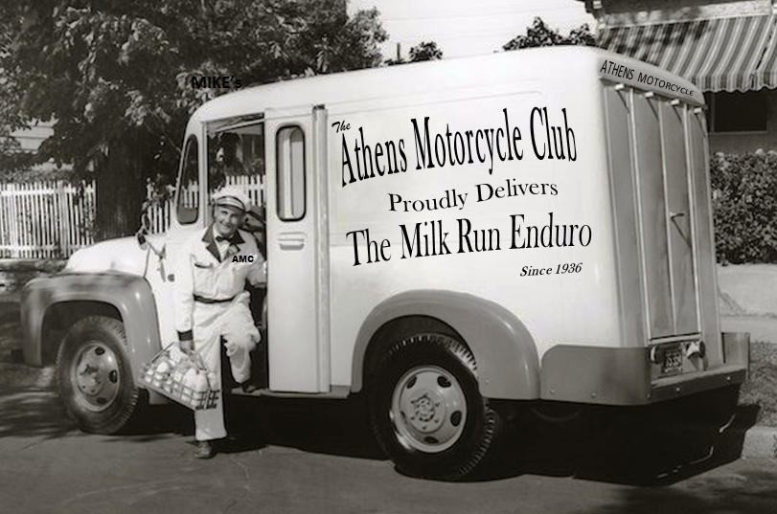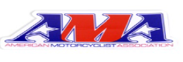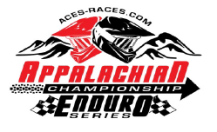

***2023 AMC Family Enduro***

***Saturday June 17th, 2023***

***CLASS PRIZES AND PRO PURSE!!!***

*Timekeeper Format *Concessions available

*Tech Inspect- Lights/Sound/Tag *Classes & Rules Info:

[www.aces-races.com](http://www.aces-races.com)

*AMA Membership required- (1 day memberships are available) *Pre-register @ **www.livelaps.com** or *Sign up 6-7pm Saturday, 7-9:30am Race Day *Pre Race Info: Kevin Brown 740-590-3490, Alan Trout 740-591-3985

**2023 Milk Run Enduro**

**Sunday June 18, 2023**

1408 Ellis Run Rd., Cutler OH 45724

**AMA Ohio State Championship**

75th Annual